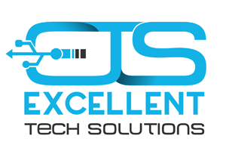

Excellent Tech Solutions

1240 Commerce Dr., Gulf Shores, AL 36542

Office phone #: 251-929-9404

All the IT Support your business needs and more.

Services:

* Hardware installation, maintenance and repair
* Software installation and support
* Cyber security solutions
* Telephony / VoIP
* Cabling and wiring
* Network design, setup, maintenance and troubleshoot
* Help Desk
* Data backup and disaster recovery
* Mobile device support and repair.
* Audio/Video systems design, installation and maintenance
* Video surveillance systems installation and maintenance
* Smart appliance integration
* Graphic Design and Print Media